**MINTER – NFT (OUTPUTS – SCREENSHOTS)**

* Installing Hardhat-ethers

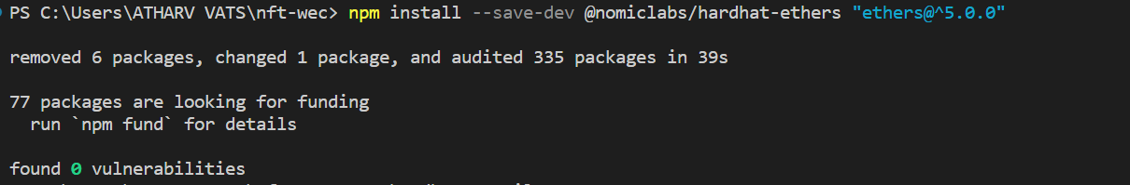

* Output on npx hardhat compile and deploying

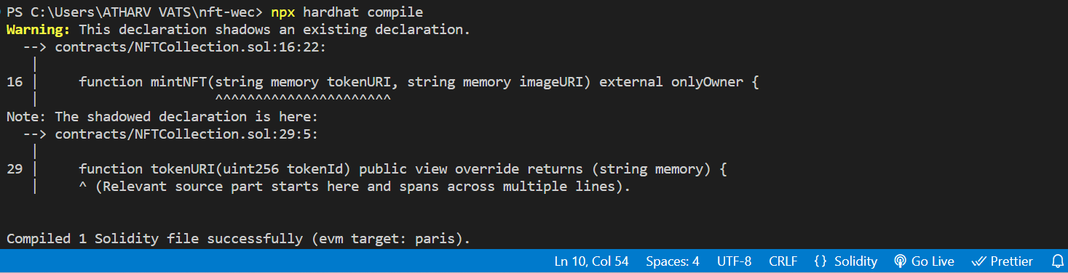

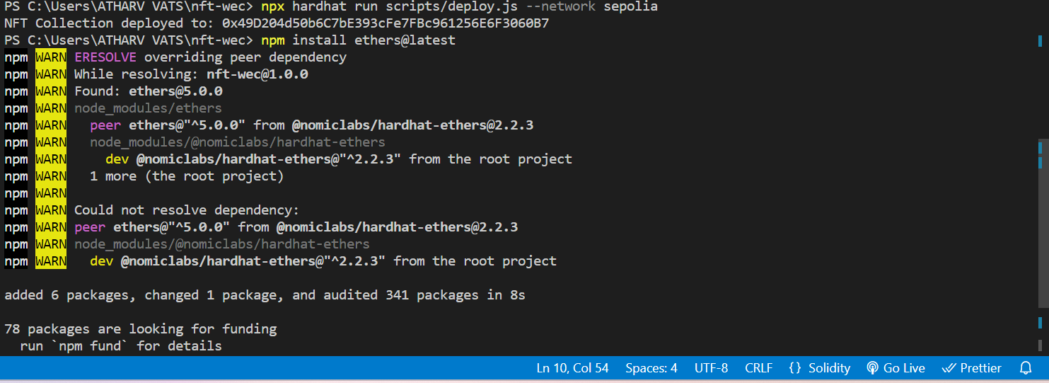

* On etherscan (deployed contract)

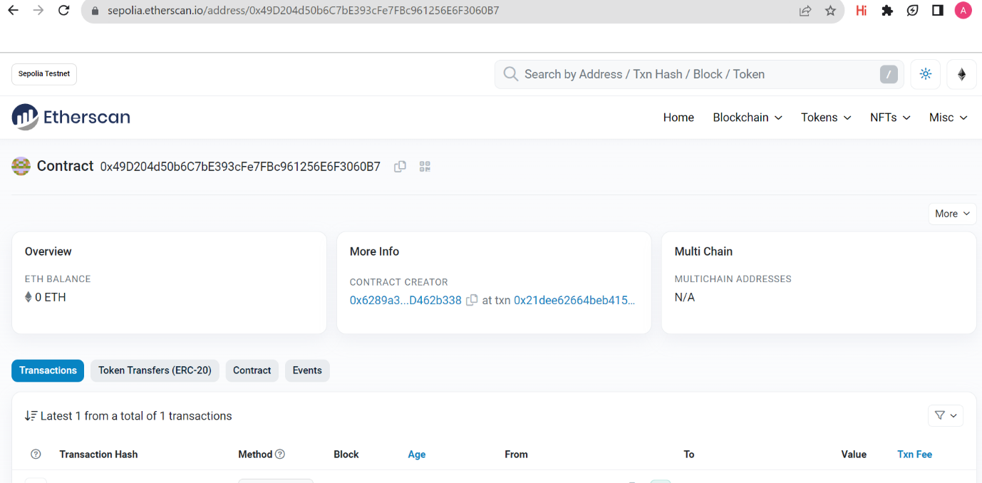

* Pinata – Token Uri (metadata file nft-metadata.json)

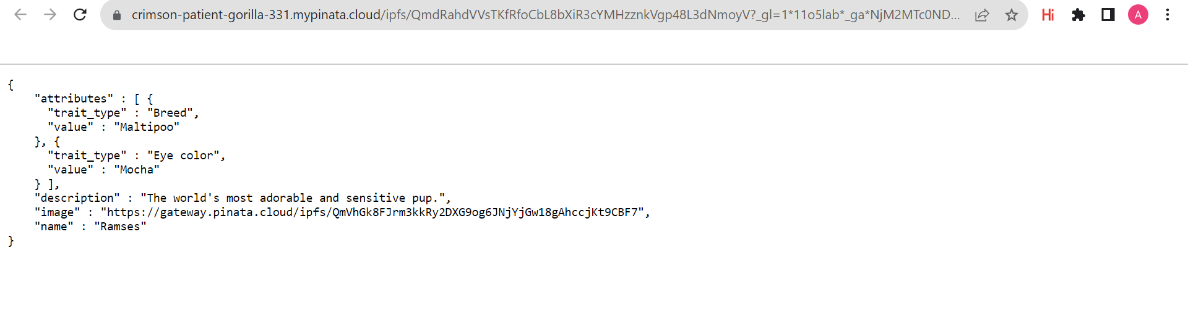

* Output on minting



* On etherscan (minted contract)

